- Main Cabinet and Sub Cabinet Configuration
First: Connect the main cabinet and the sub cabinet via the following cables.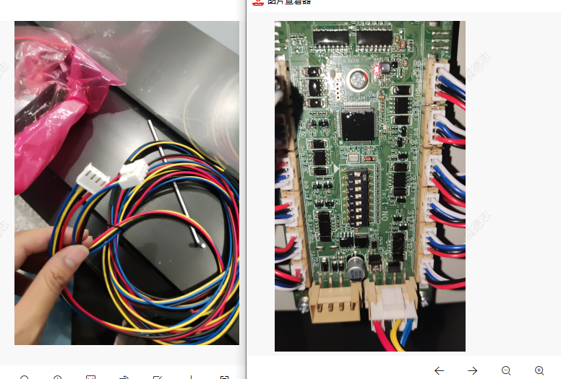

"Step 2: If the sub cabinet is located on the left side of the main cabinet, configure the DIP switches of the sub cabinet as No.1-8 according to the corresponding screenshot in the QSG (Quick Start Guide), and if the sub cabinet is located on the right side of the main cabinet, configure the DIP switches of the sub cabinet as No.9-16 per the same QSG screenshot."

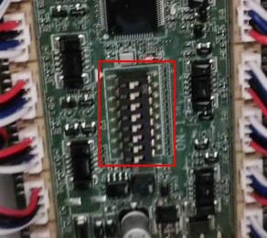

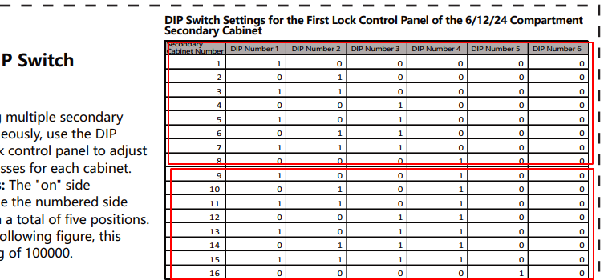

Step 3: Based on the actual physical arrangement, add the slave cabinet to the left or right side of the main cabinet in the WEB 。